Obstacle Avoidance in Mobile Robotics

Introduction
Obstacle avoidance is a fundamental area of study in the field of robotics, essential for enabling autonomous robots to navigate through their environments safely and efficiently. This capability is crucial for a wide range of applications, from industrial automation and autonomous vehicles to service robots in domestic and public spaces. The primary goal of obstacle avoidance is to enable a robot to detect objects in its path and execute appropriate maneuvers to avoid collisions, all while progressing towards its intended destination.
Local obstacle avoidance focuses on changing the robot’s trajectory based on sensor inputs during motion, where the robot’s movement is influenced by both its current or recent sensor readings and its goal position, including its relative location to the goal. The obstacle avoidance algorithms vary in their reliance on a global map and the robot’s precise knowledge of its location relative to the map. Despite their differences, all these algorithms play a critical role in determining the robot’s future trajectory through local sensor readings. Initially, simple obstacle avoidance systems like the Bug algorithm, which uses only the most recent sensor values and approximate direction of the goal, are introduced for their successful application in mobile robotics. Subsequently, more sophisticated algorithms are discussed, incorporating recent sensor history, robot kinematics, and dynamics, highlighting the evolution and depth of strategies developed for effective navigation and obstacle avoidance.
Importance of Obstacle Avoidance in Autonomous Systems
The importance of obstacle avoidance in autonomous systems cannot be overstated. It is a critical component that enables robots and autonomous vehicles to navigate through their environments safely and efficiently, ensuring the successful completion of tasks without human intervention. This capability is crucial across a wide array of applications, each presenting unique challenges that obstacle avoidance technologies aim to address.
Safety: One of the most critical aspects of obstacle avoidance is ensuring the safety of both the autonomous system itself and the entities around it. For example, in the context of autonomous vehicles, effective obstacle avoidance systems are vital to prevent collisions with pedestrians, other vehicles, and infrastructure. An autonomous car must be able to detect a child running into the street or a sudden obstacle, like fallen debris, and take immediate action to avoid a potentially dangerous situation.
Efficiency and Reliability: Obstacle avoidance also plays a significant role in enhancing the efficiency and reliability of autonomous systems. In industrial applications, such as automated guided vehicles (AGVs) in warehouses, the ability to dynamically navigate around unexpected obstacles like misplaced inventory or human workers ensures that operations proceed smoothly without interruptions. This reliability is essential for industries relying on just-in-time delivery systems, where any delay can have significant downstream effects.
Exploration and Accessibility: In exploration scenarios, such as space rovers or underwater vehicles, obstacle avoidance is crucial for accessing remote or previously unreachable areas. The Mars rovers, for instance, rely heavily on obstacle avoidance technologies to navigate the Martian terrain, avoiding rocks, crevices, and steep inclines to gather scientific data. Similarly, autonomous underwater vehicles (AUVs) navigate complex underwater landscapes to conduct research, inspect infrastructure, or map the ocean floor, all made possible by advanced obstacle detection and avoidance systems.
Service and Assistance: In the domain of service robotics, including domestic robots and personal assistants, obstacle avoidance ensures that these systems can coexist safely and effectively with humans. For example, robotic vacuum cleaners use obstacle avoidance to navigate around furniture, pets, and stairs, ensuring thorough cleaning without requiring human oversight. Similarly, in healthcare settings, robots equipped with obstacle avoidance technologies can deliver supplies, guide patients, and assist staff without impeding hospital operations or compromising patient safety.
Autonomous Drones: Drones, used for delivery, surveillance, and photography, must navigate through complex airspaces, avoiding birds, buildings, and other drones. Obstacle avoidance technologies enable drones to adjust their flight paths in real-time, ensuring safe and efficient operation whether in urban environments or rural areas.
Future Implications: The continued development of obstacle avoidance technologies is paving the way for more advanced and fully autonomous systems. As these technologies evolve, incorporating more sophisticated sensors, AI, and machine learning algorithms, the potential applications for autonomous systems expand. This includes not only improvements in existing applications but also the emergence of new services and capabilities, further integrating autonomous systems into daily life and work processes.

In conclusion, obstacle avoidance is a foundational technology for the autonomy of robotic systems, enabling safe, efficient, and reliable operation across a myriad of applications. Its development and refinement continue to be a primary focus within robotics research and development, driving forward the capabilities and possibilities of autonomous technologies.

Challenges of Avoiding Obstacle for Mobile Robots
Dynamic and Unpredictable Environments: The real world isn't static. A robot designed to operate in a warehouse might encounter unexpected boxes moved by human workers, or a drone could come across a flock of birds. It's not enough to only avoid pre-mapped obstacles – robots must make sense of a changing world on the fly.
Imperfect Sensors: No sensor is perfect. LIDAR might mistake reflections for obstacles, ultrasonic sensors can be thrown off by unusual surfaces, and camera-based vision can be affected by lighting changes, making real-world sensing messy. Obstacle avoidance algorithms need to robustly handle this noisy, imperfect data.
Real-Time Decision-Making: Robots don't have the luxury of unlimited processing time. When encountering an obstacle, they need to compute a safe and feasible alternative path quickly, especially if moving at higher speeds. This necessitates a combination of efficient algorithms and sufficient onboard computational power.
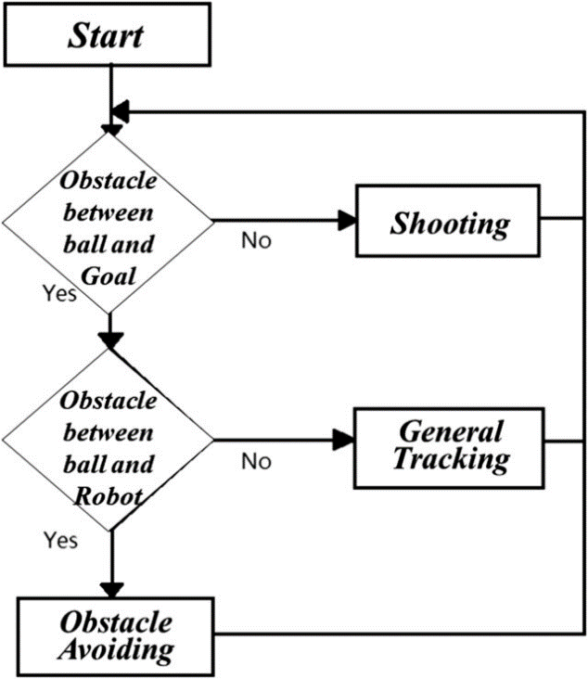
Image: A simple flowchart outlining the process of sensor input, obstacle detection, potential path evaluation, and final action, highlighting the need for real-time computation and updates as a situation evolves.
Balancing Smoothness and Reactivity: Simply avoiding obstacles isn't always enough. In many cases, a robot should avoid unnecessary jerky maneuvers to conserve energy and ensure the stability of any objects it might be carrying. Yet, sometimes sudden movements can be necessary. Algorithms need to balance smoothness with the imperative of immediate collision avoidance.
Unknown vs. Known Obstacles: In a fully explored environment, a robot might have a comprehensive map of static obstacles. In this case, planning longer and more optimal paths around them is the focus. However, unexpected obstacles require more reactive navigation to immediately ensure safety. Algorithms must often combine both planned and reactive modes.

Sensor Technologies
Let’s talk about the key sensor types commonly used for obstacle detection by mobile robots:
LIDAR
- Principle: Measures distances by emitting laser pulses and analyzing the time it takes for the light to reflect. Provides a detailed point cloud representing the robot's surroundings.
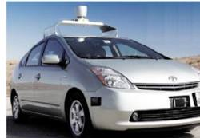
Image: Velodyne, Ouster, and Quanergy are popular LIDAR manufacturers. Many self-driving cars use rooftop-mounted LIDAR units.
- Strengths:
  - Highly accurate over long ranges.
  - Ideal for building intricate environment maps.
  - Relatively unaffected by lighting conditions.
- Weaknesses:
  - Can be expensive.
  - Point cloud data requires computational resources to process.
  - Susceptible to inaccuracies based on reflective surfaces.
Ultrasonic Sensors
- Principle: Emit sound waves and measure the time of flight for echoes to return, indicating the distance to objects.
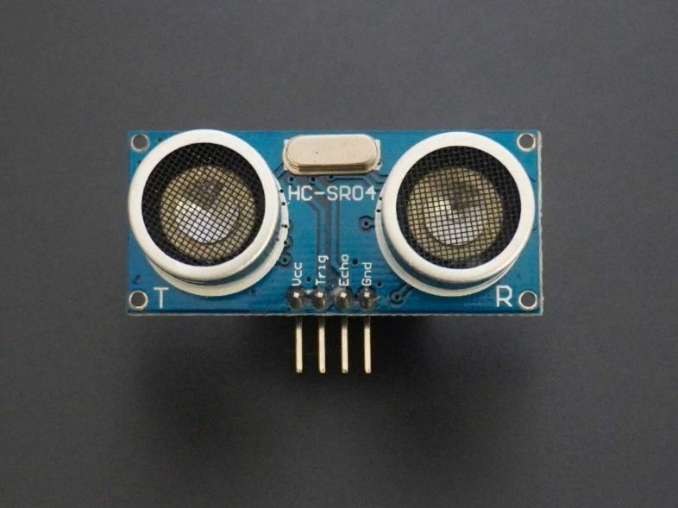
Image: Ideal for simple robots, proximity-based obstacle detection, and parking assist systems in cars.
- Strengths:
  - Very affordable and simple to use.
  - Well-suited for short-range detection.
- Weaknesses:
  - Limited range and accuracy compared to LIDAR.
  - Can be affected by the shape and material of objects (sound absorption).
  - Readings can be thrown off by environmental interference from other sound sources.
Computer Vision (Stereo/Monocular)

- Principle: Uses cameras to capture images. Through stereo vision (two cameras) or monocular depth estimation techniques, distances to objects and features in the scene can be inferred.

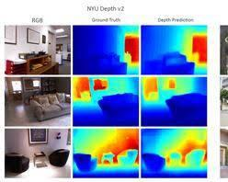
Image: Stereo cameras are found in some advanced robots and VR headsets. Monocular vision is increasingly used due to low cost and computational advances.
- Strengths:
  - Rich source of information – not just distance, but potential obstacle classification (car, person, etc.).
  - Good for complex, textured environments.
- Weaknesses:
  - Can be computationally demanding.
  - Accuracy impacted by lighting, shadows, and visual ambiguities (transparent objects).
  - Depth estimation can be less precise at a distance compared to LIDAR.

Obstacle Avoidance Algorithms

Bug Algorithms
The Bug algorithm [101, 102] is perhaps the simplest obstacle avoidance algorithm one could imagine. The basic idea is to follow the contour of each obstacle in the robot’s way and thus circumnavigate it.
Core Idea: Bug algorithms combine goal-seeking with obstacle boundary following to get a robot to its destination. At their heart, they provide a simple set of rules:
- Move towards the goal: Initially, the robot moves in a straight line towards its target.
- Obstacle encountered: If an obstacle blocks its path, stop.
- Follow the obstacle boundary: Circumnavigate the obstacle's perimeter, keeping track of the closest point to the goal encountered along the way.
- Leave Condition: When the robot, while following the obstacle's edge, finds a point on the boundary that is closer to the goal than any encountered so far and also lies on the direct line of sight to the goal, it leaves the obstacle and resumes moving directly towards the goal.
Bug 1 vs. Bug 2
- Bug 1: The simplest variant. Sometimes this results in the robot completely circumnavigating an obstacle before rediscovering the direct path to the goal, even if shorter detours might be available.
- Bug 2: Improves efficiency. Upon encountering an obstacle, the robot places a virtual 'leaving marker' (the hit point). While going around the obstacle, if it intersects its original straight-line trajectory before returning to the hit point, it can leave the obstacle earlier and shorten the circumnavigation.
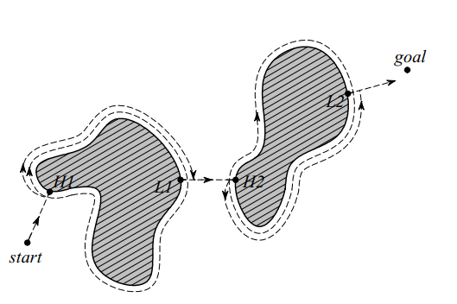
Image: Bug1 algorithm with H1, H2, hit points, and L1, L2, leave points
With Bug1, the robot fully circles the object first, then departs from the point with the shortest distance toward the goal. This approach is, of course, very inefficient but guarantees that the robot will reach any reachable goal.

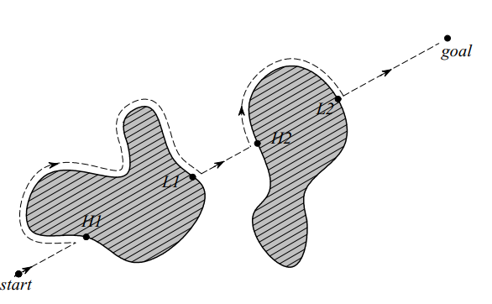
Image: Bug2 algorithm with H1, H2, hit points, and L1, L2, leave points
With Bug2 the robot begins to follow the object’s contour but departs immediately when it can move directly toward the goal. In general, this improved Bug algorithm will have significantly shorter total robot travel, as shown in figure. However, one can still construct situations in which Bug2 is arbitrarily inefficient (i.e., nonoptimal).
A few variations and extensions of the Bug algorithm exist. We mention one more, the tangent Bug, which adds range sensing, and a local environmental representation termed the local tangent graph (LTG). Not only can the robot move more efficiently toward the goal using the LTG, it can also go along shortcuts when contouring obstacles and switch back to goal seeking earlier. In many simple environments, tangent Bug approaches globally optimal paths.

Vector Field Histogram
Borenstein, together with Koren, developed the vector field histogram (VFH). Their previous work, which was concentrated on potential fields, was abandoned due to the method’s instability and inability to pass through narrow passages. Later, Borenstein, together with Ulrich, extended the VFH algorithm to yield VFH+ and VFH*.
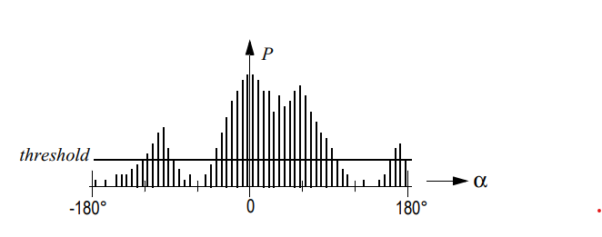
Image: Polar Histogram
One of the central criticisms of Bug-type algorithms is that the robot’s behavior at each instant is generally a function of only its most recent sensor readings. This can lead to undesirable and yet preventable problems in cases where the robot’s instantaneous sensor readings do not provide enough information for robust obstacle avoidance. The VFH techniques overcome this limitation by creating a local map of the environment around the robot. For obstacle avoidance, VFH generates a polar histogram as shown in figure 6.9. The x-axis represents the angle at which the obstacle was found, and the y-axis represents the probability that there really is an obstacle in that direction based on the occupancy grid’s cell values.
From this histogram a steering direction is calculated. First all openings large enough for the vehicle to pass through are identified. Then a cost function is applied to every such candidate opening. The passage with the lowest cost is chosen. The cost function has three terms:
G = a ⋅ target_direction+b ⋅ wheel_orientation+c ⋅ previous_direction
target_direction = alignment of the robot path with the goal.
wheel_orientation = difference between the new direction and the current wheel orientation.
previous_direction = difference between the previously selected direction and the new direction.

The terms are calculated such that a large deviation from the goal direction leads to a big cost in the term “target direction”. The parameters in the cost function tune the behavior of the robot. For instance, a strong goal bias would be expressed with a large value for. For a complete definition of the cost function.

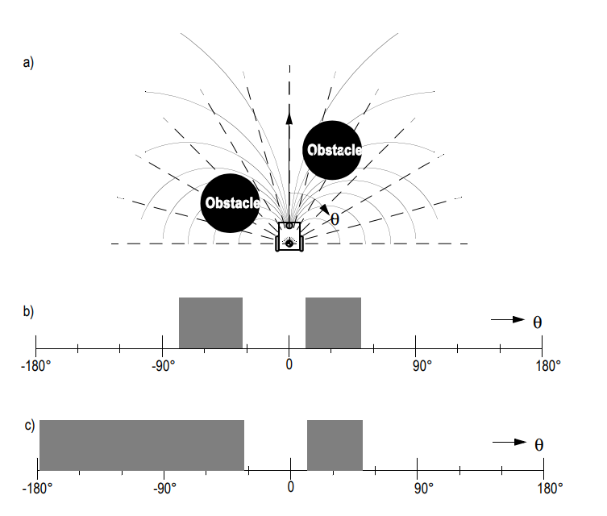
Image: Example of blocked directions and resulting polar histograms [54]. (a) Robot and blocking obstacles. (b) Polar histogram. (b) Masked polar histogram
In the VFH+ improvement one of the reduction stages considers a simplified model of the moving robot’s possible trajectories based on its kinematic limitations (e.g., turning radius for an Ackerman vehicle). The robot is modeled to move in arcs or straight lines. An obstacle thus blocks all the robot’s allowable trajectories which pass through the obstacle. This results in a masked polar histogram where obstacles are enlarged so that all kinematically blocked trajectories are properly considered.

Obstacle avoidance with SLAM and Path Planning

SLAM
SLAM stands for Simultaneous Localization and Mapping, which is a computational problem and a key technology enabling autonomous robots and vehicles to construct or update a map of an unknown environment while simultaneously keeping track of their own location within that environment.
The SLAM problem combines two major challenges:
- Localization: Determining where the robot is with respect to the environment. Even when a map is available, a robot still needs to locate itself within that map, which can be challenging without external reference points like GPS.
- Mapping: Creating a map of the environment. In many cases, autonomous systems operate in environments where no map is available, or the map needs updating due to dynamic changes.
SLAM algorithms consider the noise and inaccuracy inherent in sensor data and the robot's motion. They typically involve complex mathematical models that estimate probabilities for various possible states of the robot and the map.
SLAM is critical for autonomous systems as it allows for:
- Autonomous Exploration: Robots can navigate uncharted environments, which is essential for applications like planetary rovers, underwater exploration, and search-and-rescue operations.
- Indoor Navigation: GPS is not reliable indoors, so robots and vehicles rely on SLAM for navigation in places like malls, airports, and warehouses.
- Dynamic Environments: SLAM can adapt to changes within environments, making it essential for robots to work in places where the layout may change frequently, such as in homes or dynamic workplaces.
SLAM algorithms use a variety of sensor inputs, including cameras (visual SLAM), LIDAR, ultrasonic sensors, or a combination of these. The specific algorithms and sensor configurations used can vary widely depending on the application, the desired accuracy, and computational constraints.

Path Planning
Path planning is a computational process used in robotics and autonomous systems to find a viable route from a starting point (the robot's current location) to a destination point (the goal) while navigating through an environment that may contain obstacles. It involves creating a pathway that a robot can follow, taking into consideration the robot's physical dimensions, capabilities, and the nature of the terrain. The primary goal is to determine the most efficient, safest, and, sometimes, the most cost-effective path.
Key Aspects of Path Planning:
- Environment Representation: The environment can be represented in different ways, such as grid maps, topological maps, or geometric maps. The representation choice often depends on the application and the complexity of the environment.
- Robot Capabilities: The path planning algorithm must consider the robot's kinematic and dynamic constraints, such as its ability to turn, speed, and acceleration capabilities.
- Obstacle Avoidance: A vital part of path planning is ensuring that the robot avoids collisions with static or dynamic obstacles detected in the environment.
- Optimization Criteria: Path planning may involve optimizing various factors, including the shortest distance, minimum travel time, energy efficiency, or even the smoothness of the path.

Integrating obstacle avoidance with Simultaneous Localization and Mapping (SLAM) and path planning is essential for the development of sophisticated autonomous systems capable of operating in complex and dynamic environments.
The Need for Integration:
- Obstacle Avoidance in a Vacuum: A robot with sophisticated obstacle avoidance, but no awareness of its larger environment or goals, will simply wander. Imagine a Roomba-like robot perfectly avoiding furniture, but never being able to find its charging dock.
- Maps as Essential Context: SLAM (Simultaneous Localization and Mapping) enables the robot to build a representation of its surroundings. This map is crucial for obstacle avoidance; paths cannot be planned around unknown elements. Additionally, obstacles detected during avoidance maneuvers need to be integrated into the map for a consistent world model.
- Planning's Dependence on Knowledge: Path planning algorithms leverage maps. Efficient routes require knowing not just if an obstacle exists, but where it exists. An unmapped obstacle is an unsolvable navigation problem to a path planner.
Obstacle Avoidance Cannot Operate in Isolation:
- Maps for Planning: While reactive obstacle avoidance is useful for immediate responses to the environment, for strategic navigation and mission planning, an understanding of the environment is necessary. Maps provide this context and allow for the identification of the most efficient paths, areas of interest, and potentially hazardous zones that need more careful navigation.
- Obstacle Locations and Mapping: As a robot moves through an environment, it needs to update its map with the location of obstacles. This mapping is not static; it needs to account for dynamic changes. Obstacles detected via avoidance algorithms are added to the map, which then informs future path planning decisions.
- Consistency and Learning: Over time, the integration of obstacle avoidance with mapping allows the robot to learn from repeated encounters with obstacles, improving its ability to predict and react to similar situations in the future.

Real-World Application: Self-Driving Cars:

Why Obstacle Avoidance is Fundamental
Self-driving cars don't just need to get from point A to point B. They need to do so safely. Obstacle avoidance is what prevents:
- Collisions: Avoiding collisions with other vehicles, pedestrians, animals, and roadside objects is the most obvious priority for any autonomous vehicle.

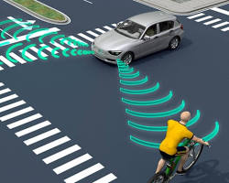
Image: self-driving car with other road obstacles around it
- Traffic Violations: Traffic lights, stop signs, and lane markings also act as 'obstacles' which must be detected and appropriately reacted to.
- Navigation Errors: Road debris, sudden lane closures due to construction, or other unexpected blockages necessitate rerouting – all built upon obstacle avoidance.
- Legal and Ethical Considerations: Autonomous vehicles must adhere to traffic laws and make decisions that minimize harm in unavoidable accident scenarios. Effective obstacle avoidance systems are critical for navigating these complex situations.
Unique Challenges at Varying Driving Speeds
- Low Speed (Urban):
  - High Density: Many types of obstacles (cars stopping suddenly, pedestrians crossing, bikes, open car doors).
  - Limited Reaction Time: Stopping distances are shorter, so the AI must analyze complex visual input and decide extremely quickly.
  - Prediction Required: Intentions of humans are harder to model than vehicle behavior, which can add uncertainty.
- Highway Speeds
  - Longer Perception Range: The car needs to 'see' far ahead to detect things like stalled vehicles or lane changes early.
  - Reduced Maneuverability: It's harder to change lanes quickly or brake harshly; emphasis is on smooth, preemptive avoidance.
  - Relative Velocity Matters: Closing speed (difference in velocity between vehicles)
- Sensor Fusion and Data Processing
  - Effective obstacle avoidance at any speed relies on integrating data from multiple sensors, including cameras, radar, LIDAR, and ultrasonic sensors. Processing this data to accurately detect obstacles and predict their movement requires sophisticated algorithms and significant computational power.is a factor; misjudging a fast-moving truck becomes much more dangerous.
- Machine Learning and AI
  - Self-driving cars use machine learning models to improve obstacle detection and avoidance strategies over time. These models are trained on vast datasets of driving scenarios but must also be capable of adapting to novel situations not encountered during training.
- Weather and Environmental Conditions
  - Adverse weather conditions like rain, fog, snow, or glare from the sun can impair the sensors' ability to detect obstacles. Developing systems that can operate reliably in all weather conditions is a significant challenge.

